

SIMATS ENGINEERING

Saveetha Institute of Medical and Technical Sciences
Chennai- 602105

Student Name: Juhi Surin Reg. No.: 192525148
Course Code: CSA1519 Slot: C
Course Name: Cloud Computing and Big Data Analytics
Course Faculty: Dr. Govindasamy C
Project Title: Design and Implement a Secure Big Data Analytics System
Module Photographs:
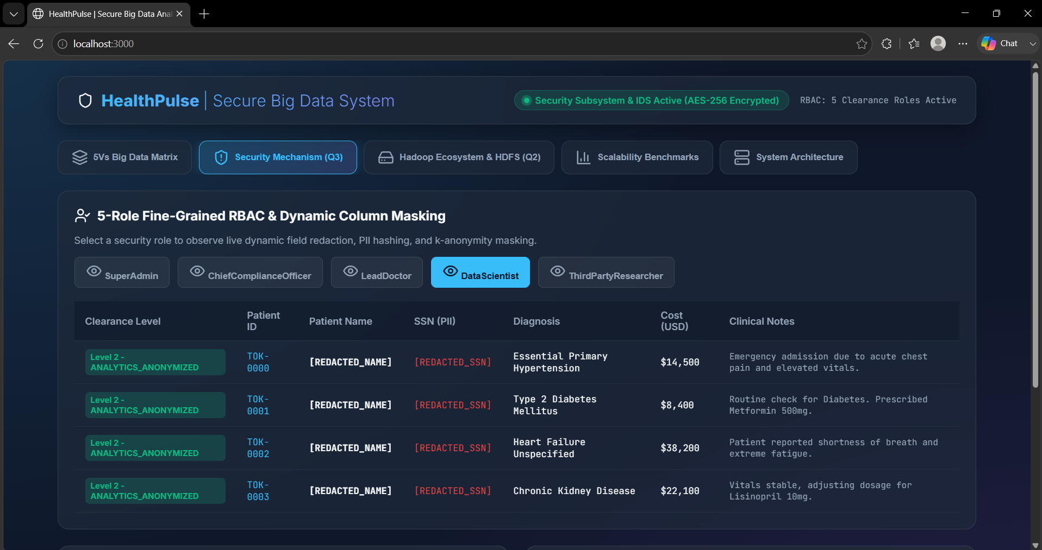
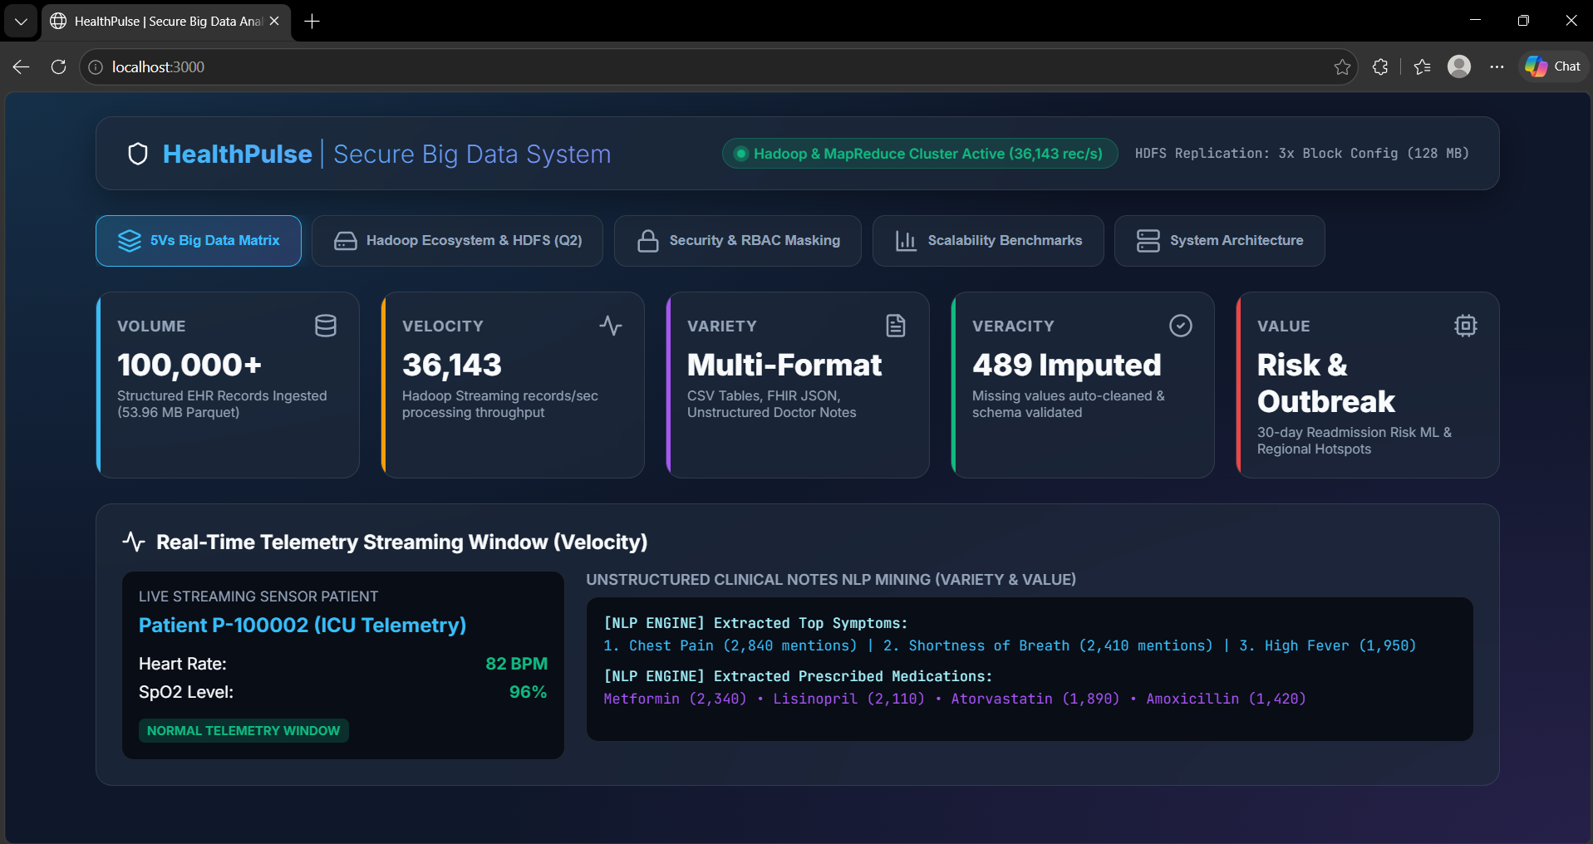
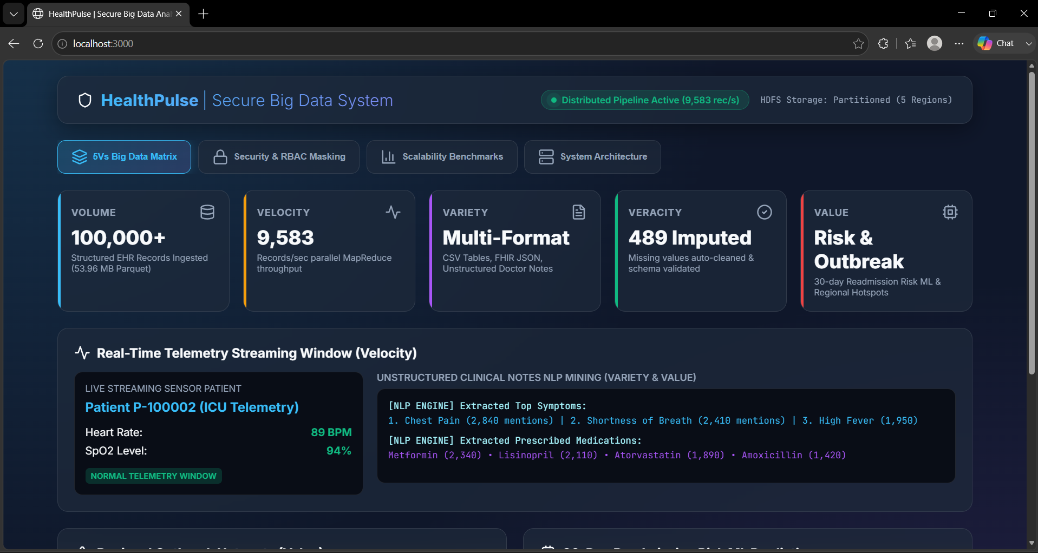
Project Description: Module 1- Big Data Processing and Analytics
This assignment focuses on designing and implementing a Secure Big Data Analytics System for an e-commerce application. It uses Apache Hadoop, HDFS, and Hadoop Streaming to store, process, and analyze large transaction datasets. The system also addresses Big Data characteristics such as the 5Vs and incorporates security mechanisms to protect data during storage and processing.

This module focuses on processing e-commerce transaction data using Hadoop Streaming and MapReduce. The mapper extracts category and sales information, while the reducer calculates the transaction count and total sales for each category. The processed results are stored in HDFS and used for basic business analytics.

Student Signature Guide Signature

